Multiple choice section

Question 1 [6.2]

The perimeter of a square with a side length of 315 mm is:

A 0.63 m B 1.26 m C 6.3 m D 12.6 m

Question 2 [6.6]

A rectangular prism with length 2 m, width 1.2 m and height 75 cm, has a volume of:

A 1.8 m3 B 18 m3 C 78.2 m3 D 180 m3

Question 3 [7.1]

The number missing from the true number sentence 5 × \_\_\_ = 51 − 6 is:

A 6 B 8 C 9 D 21

Question 4 [7.3]

When using backtracking to solve , the first step is to:

A divide by 5 B add 6 C multiply by 2 D subtract 8

Question 5 [7.2]

A tub of lollies is divided evenly between 12 people. Each person receives 13 lollies.

If n represents the number of lollies in the tub, the equation that can be formed is:

A n − 12 = 13 B 13n = 12 C  D 

Question 6 [8.1]

To draw a 310° angle with a semicircular protractor, which angle would you draw first?

A 300° B 270° C 90° D 50°

Question 7 [8.3]

The value of x in the diagram is:

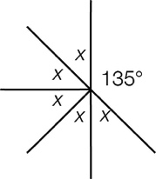

A 9° B 45° C 65° D 135°

Question 8 [8.5]

The shape shown is:

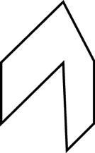

A a hexagon B a heptagon C a noctagon D a nonagon

Question 9 [8.7]

The size of angle a is:

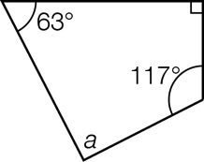

A 63° B 80° C 90° D 117°

Question 10 [9.2]

The following data represents the number of brothers and sisters for 10 students in a class:  
 1, 2, 3, 1, 3, 2, 3, 4, 2, 1

The median number of brothers and sisters for this group of students is:

A 1 B 2 C 2.2 D 2.5

Question 11 [10.1]

How has the pentagon in the diagram below been translated?

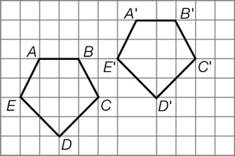

A 5 units right and 2 units down B 5 units left and 2 units down

C 5 units right and 2 units up D 5 units left and 2 units up

Question 12 [10.6]

The number of cubes required to build the shape shown:

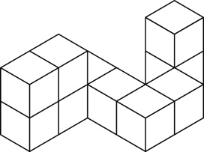

A 9 B 10 C 11 D 12

Multiple choice total:\_\_\_\_\_\_\_\_\_/12

Short answer section

Question 13 4 marks [6.3]

(a) Find the area (in km2) of a rectangle with length 4.7 km and width 750 m.

(b) Find the area (in cm2) of a rectangle with length 225 mm and width 12 cm.

Question 14 2 marks [6.4]

For the parallelogram shown:

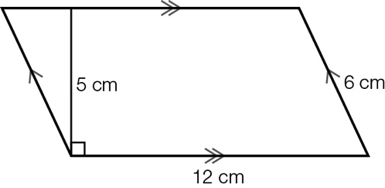

(a) find the area

(b) find the perimeter.

Question 15 4 marks [6.5]

Calculate the shaded area of the composite shape below.

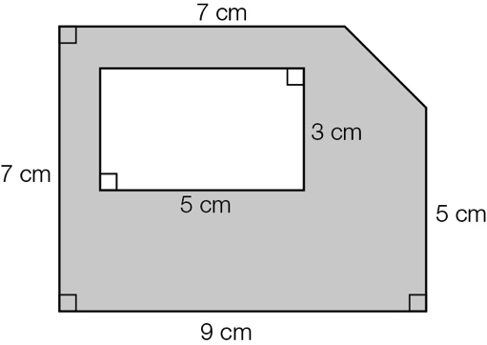

Question 16 4 marks [7.4]

Solve the following equations.

(a) 5x − 2 = 13 (b) 3(x − 2) = 9 (c) 

Question 17 3 marks [7.5]

David was painting part of his house. He bought a tin of paint and a roller/tray set.

(a) If the paint cost $P and the roller/tray set cost $12.99, write an expression for the total cost $C of the purchases.

(b) Form an equation and solve it to find the cost of the paint if David spent $77.89 in total on these purchases.

Question 18 4 marks [8.2]

Using the diagram below, name, using letters:

|  |  |
| --- | --- |
| PM7_SmB_Sem2_08 | (a) an acute angle that includes point C  (b) a pair of complementary angles  (c) a pair of supplementary angles  (d) a pair of vertically opposite angles. |

Question 19 8 marks [8.4]

Find the value of each pronumeral, and give a reason for your answer.

|  |  |
| --- | --- |
| PM7_SmB_Sem2_09 | a \_\_\_\_\_\_\_\_\_\_\_\_\_\_\_\_\_\_\_\_\_\_\_\_\_\_\_\_\_  b \_\_\_\_\_\_\_\_\_\_\_\_\_\_\_\_\_\_\_\_\_\_\_\_\_\_\_\_\_  c \_\_\_\_\_\_\_\_\_\_\_\_\_\_\_\_\_\_\_\_\_\_\_\_\_\_\_\_\_  d \_\_\_\_\_\_\_\_\_\_\_\_\_\_\_\_\_\_\_\_\_\_\_\_\_\_\_\_\_ |

Question 20 3 marks [8.6]

The diagonal of a rectangle cuts the rectangle into two triangles (the length and width of the rectangle are different values).

(a) Draw a diagram of the rectangle with the diagonal described above.

(b) State the name of the triangles formed based on:

(i) the side lengths of the triangles: \_\_\_\_\_\_\_\_\_\_\_\_\_\_\_\_\_\_\_\_\_\_\_\_

(ii) the angles of the triangles: \_\_\_\_\_\_\_\_\_\_\_\_\_\_\_\_\_\_\_\_\_\_\_\_

Question 21 3 marks [9.1]

For each of the following, state whether the data from a survey asking these questions is  
categorical, discrete or continuous.

(a) How many television sets are there in your house? \_\_\_\_\_\_\_\_\_\_\_\_\_\_\_\_\_\_\_\_

(b) What is your favourite type of movie? \_\_\_\_\_\_\_\_\_\_\_\_\_\_\_\_\_\_\_\_

(c) How many minutes did it take you to travel to school today? \_\_\_\_\_\_\_\_\_\_\_\_\_\_\_\_\_\_\_\_

Question 22 2 marks [9.7]

A box of chocolates contains 12 soft-centred and 8 hard-centred chocolates.

(a) Nikki chooses a chocolate at random from the box and eats it. What is the probability that the chocolate is soft-centred?

(b) Given that Nikki chose a soft-centred chocolate with her first choice and ate it, what is the probability that the second chocolate she chooses is also soft-centred?

Question 23 5 marks [9.3]

The number of points scored by each of the teams in one round of the local AFL competition was:

99, 67, 103, 62, 67, 51, 108, 71, 120, 53, 145, 72

(a) Draw an ordered stem-and-leaf plot of the data.

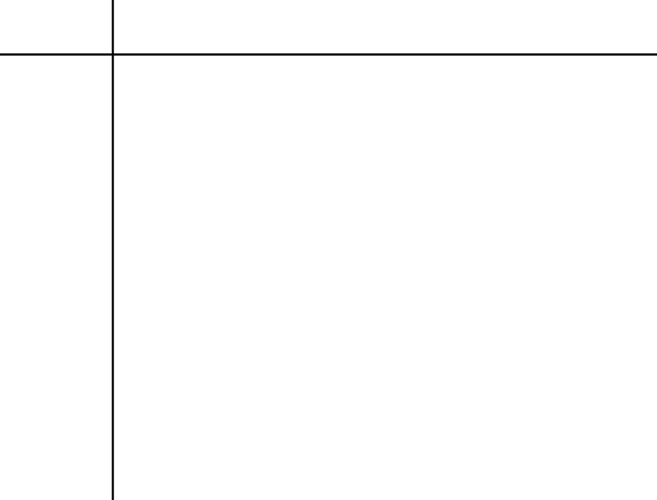

(b) Find the median score.

(c) Calculate the range of the scores.

Question 24 4 marks [10.2]

Complete the following diagrams showing the reflection of each in the line of reflection shown.

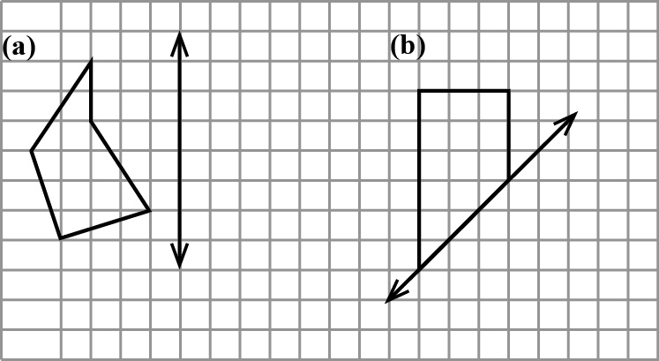

Question 25 5 marks [10.4]

(a) For the following shape, reflect along the line of symmetry and then rotate 90° in an anticlockwise direction about the centre of rotation O.

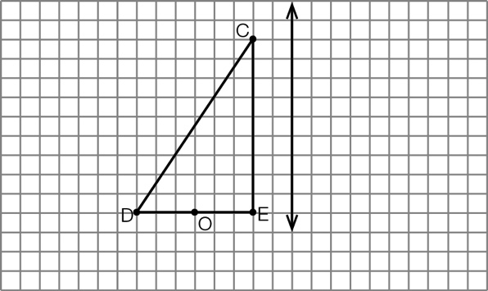

(b) For the following shape, rotate 90° in an anticlockwise direction about the centre of rotation O and then reflect along the line of symmetry.

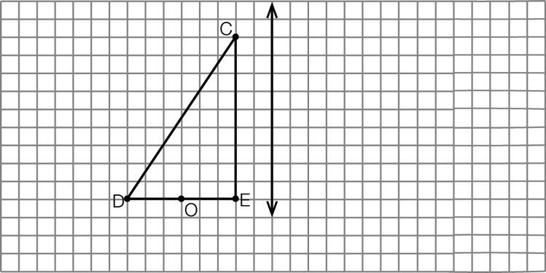

(c) Comment on the two transformed shapes obtained in (a) and (b).

Question 26 6 marks [10.7]

For the solid shown, draw the:

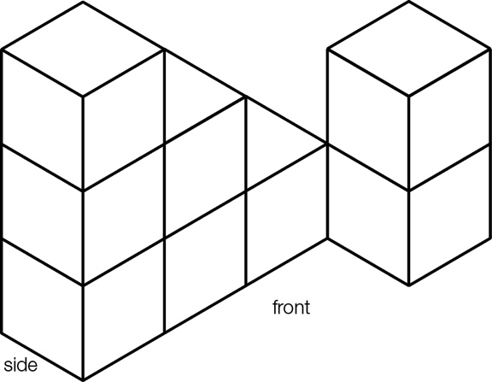

(a) top view

(b) side view

(c) front view.

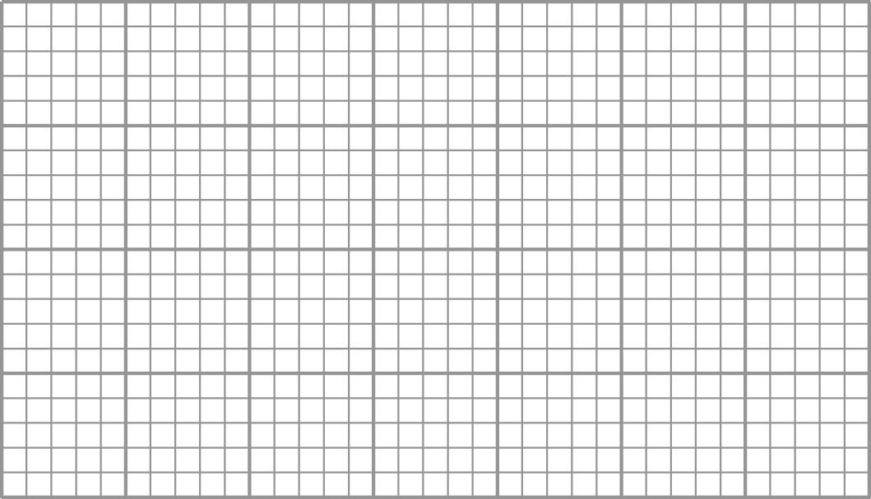

Short answer total:\_\_\_\_\_\_\_\_\_/57

Extended answer section

Question 27 10 marks [8.4, 8.6]

Find the value of each pronumeral below, giving a reason for your answer.

|  |  |  |
| --- | --- | --- |
| (a)  PM7_SmB_Sem2_16  a \_\_\_\_\_\_\_\_\_\_\_\_\_\_\_\_\_\_\_\_\_\_\_\_  b \_\_\_\_\_\_\_\_\_\_\_\_\_\_\_\_\_\_\_\_\_\_\_\_  c \_\_\_\_\_\_\_\_\_\_\_\_\_\_\_\_\_\_\_\_\_\_\_\_ | (b)  PM7_SmB_Sem2_17  d \_\_\_\_\_\_\_\_\_\_\_\_\_\_\_\_\_\_\_\_\_\_\_\_  e \_\_\_\_\_\_\_\_\_\_\_\_\_\_\_\_\_\_\_\_\_\_\_\_  f \_\_\_\_\_\_\_\_\_\_\_\_\_\_\_\_\_\_\_\_\_\_\_\_  g \_\_\_\_\_\_\_\_\_\_\_\_\_\_\_\_\_\_\_\_\_\_\_\_ | (c)  PM7_SmB_Sem2_18  h \_\_\_\_\_\_\_\_\_\_\_\_\_\_\_\_\_\_\_\_\_\_\_\_  m \_\_\_\_\_\_\_\_\_\_\_\_\_\_\_\_\_\_\_\_\_\_\_\_  n \_\_\_\_\_\_\_\_\_\_\_\_\_\_\_\_\_\_\_\_\_\_\_\_ |

Question 28 7 marks [9.5]

The graph below shows the daily rainfall (in mm) for Brisbane in April.

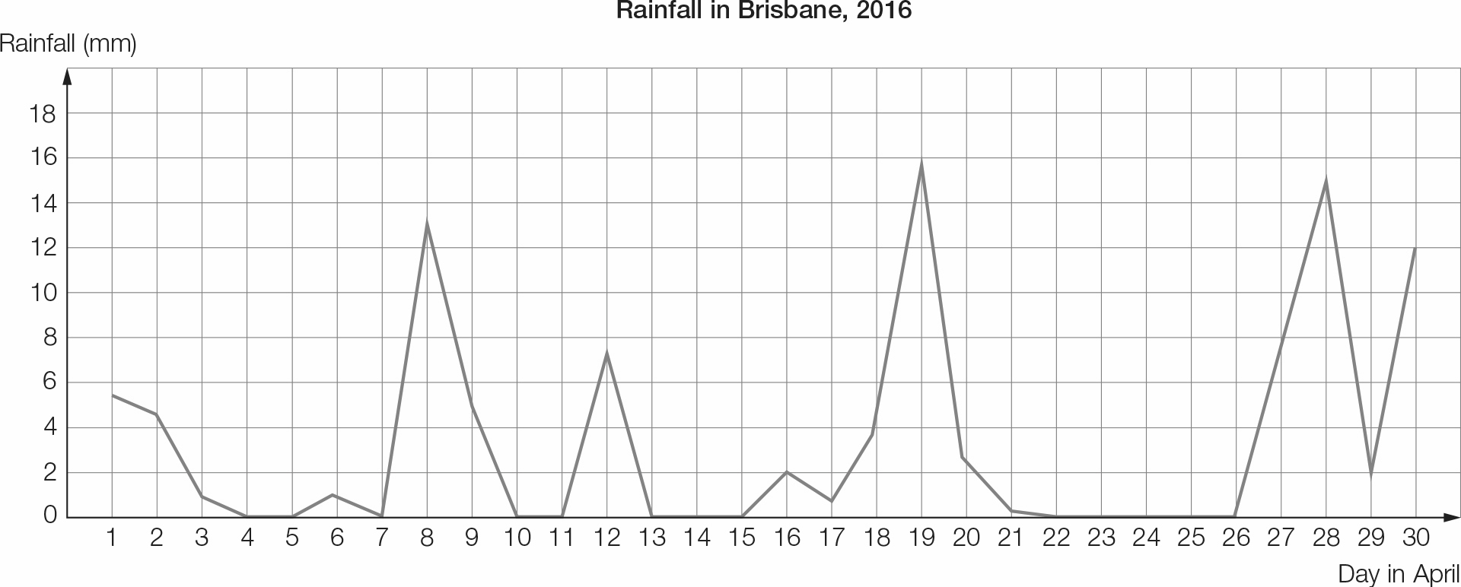

(a) On how many days was there no rainfall?

(b) To the nearest mm, what was the maximum daily rainfall for this month?

(c) On which date was this maximum rainfall achieved?

The following table gives the total rainfall at this weather station for each April in the first decade of the 2000s.

|  |  |  |  |  |  |  |
| --- | --- | --- | --- | --- | --- | --- |
| Year | 2000 | 2001 | 2002 | 2003 | 2004 | 2005 |
| Rainfall (mm) | 42.8 | 33.4 | 49.8 | 113.4 | 31.0 | 48.8 |

|  |  |  |  |  |  |  |
| --- | --- | --- | --- | --- | --- | --- |
| Year | 2006 | 2007 | 2008 | 2009 | 2010 | 2011 |
| Rainfall (mm) | 48.4 | 3.2 | 16.8 | 195.2 | 36.4 | 100.2 |

(d) Find the mean rainfall (in mm) for the years 2000−2010.

(e) Compare the April rainfall for 2011 with the mean rainfall for the previous 11 years. Comment on what you notice.

Extended answer total:\_\_\_\_\_\_\_\_\_/17

TOTAL test marks: \_\_\_\_\_\_\_\_/86